**Experiment 28: DC motor**

一：Introduction of DC motor

* A device that converts electrical energy into mechanical energy.
* Two power connectors
* When sufficient current is given at an appropriate voltage, the rotation direction is determined by the current direction.

Ordinary DC motor speed high torque is small, suitable for small torque requirements on the occasion

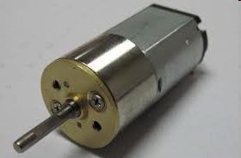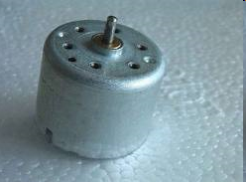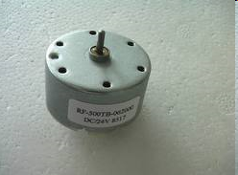

二：DC motor

* DC motor (gear motor) is based on the ordinary DC motor, plus a set of gear reducer.
* Gear reduction gearbox can provide a lower speed and larger torque, different speed ratio can provide different speed and torque
* 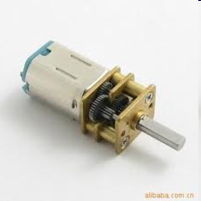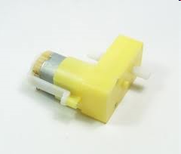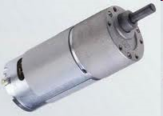

三：Common parameters

* Working voltage (rated voltage)
  + The voltage used to drive the motor.
  + Motor can work when the voltage is higher or lower than the operating voltage
  + Actual voltage < rated voltage, the output power is small
  + Actual voltage > rated voltage, will affect the life of the motor
* working current
  + The greater the motor operating current, the greater the output power
  + When the motor is running, the current of the motor is minimum (no load current).

--The load is increased to make the motor stop rotating (blocking the current).

* + torque Motor rotation force
* speed

Revolutions per minute (Rev / min, RPM)

Be careful!

* The motor is a large current device, which can not be directly controlled by the Arduino pin.

Different from LED

* + The motor voltage is higher than the working voltage of Arduino, pay attention to the isolation and wiring

--Error could cause Arduino to burn down

* Under the condition of the motor is not energized, the rotation will generate a reverse current (reverse voltage).
  + Working principle of generator
  + Contrary to the direction of the reverse current and the direction of the motor operating current
  + Reverse current will cause damage to electronic equipment.

四：wiring diagram

Drive motor with transistor or MOS tube

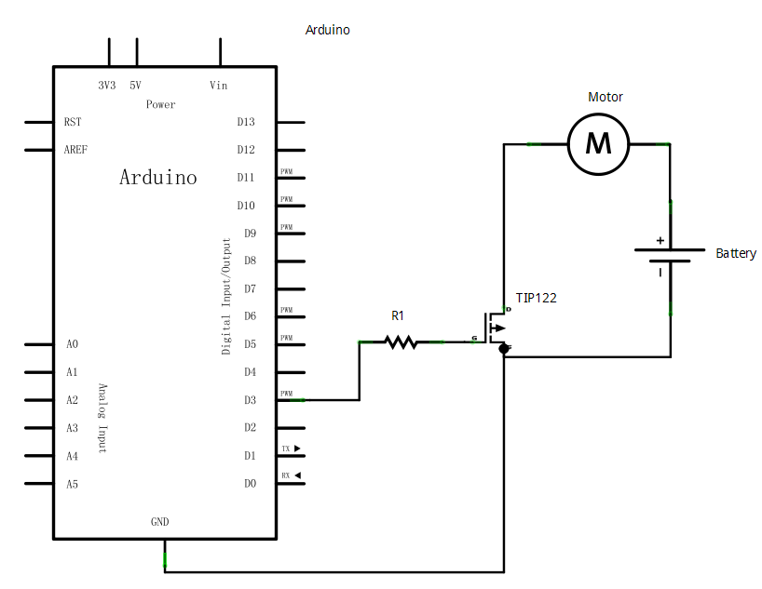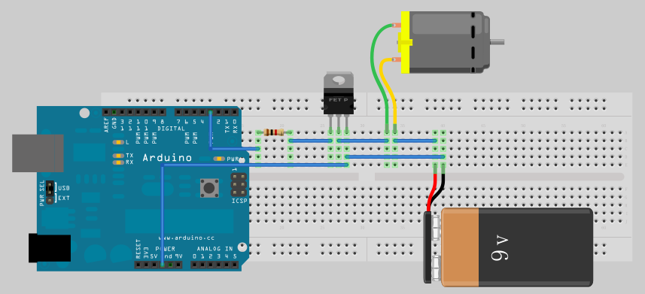

code ：

